Protein Multiple Sequence Alignment using Knowledge
Makoto Hirosawa, Masaki Hoshida, Masato Ishikawa
Proceeding of the Twenty-Sixth Hawaii International Conference on System Sciences, 1993, Page(s): 803 –812
- Introduction
- Why is an intelligent refiner necessary
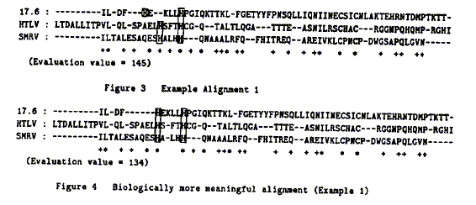
- Multiple alignment system with Intelligent Refiner
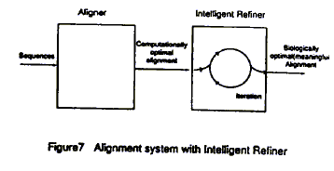

Biological knowledge base
˙C signifies cysteine.
˙X signifies any amino acid.
˙C(4) is the string of C whose length is four.
˙X(3, 5) is the string of X whose length is from three to five.
˙[LIV] signifies an amino acid signified by L or I or V.
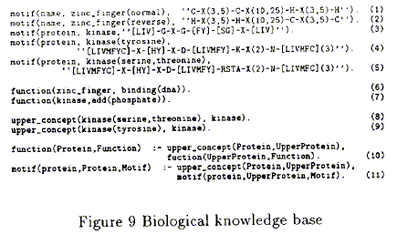
Refinement rule base
General rules and Specific rules
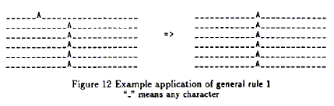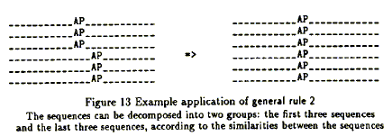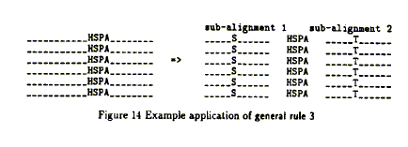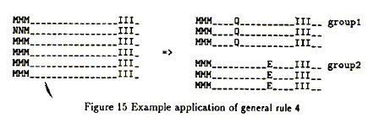
- Discussion
Created by : Ming-Cheng Lin
Date : May 3, 2000

